The Future of MagLev: How the Magnetic-Levitation SuperTurnpike will Revolutionize Ground Transportation
by Joshua Zev Levin, Ph.D. (blogging as Dr. Zev)

Abstract
This paper has five main sections. The first one describes the evolution of Superconducting Magnetic Levitation (SC MagLev), as invented half a century ago by two scientists at Brookhaven National Laboratories (BNL) on Long Island, these being the late Drs. James R. Powell and Gordon T. Danby. They devised two generations of SC MagLev. The first generation, using dipole magnets, will soon be in use in Japan for passenger service. The second generation (2G), developed in the 1990s and early 2000s, uses quadrupole magnets and has many advantages, such as switching and the ability to carry freight, including fully-loaded trucks.
The second section describes how one would start testing and then building a MagLev system. This includes a test bed, probably located in a rural/wilderness area; and later on short-range freight and passenger service, with speeds much lower than the 300 mph of the final system. These systems can provide useful services for passengers and freight, help get people used to the benefits of MagLev, as well as turn a profit that can be re-invested in future MagLev systems. These will later be expanded into an intercity system, at a full 300 mph, as per plans from Powell, Danby, and their associates.
The third section describes how enhancements to the 2G MagLev can be used to make it much more useful. It can convey passengers riding individual cars practically from door-to-door over long distances. Having MagLev lines go directly into hotels and resorts can enhance the passenger experience, while having them go to hospital emergency departments can make sure passengers who are unlucky enough to fall ill while traveling can get immediate aid. For freight, having MagLev lines go directly to factories, warehouses, and shopping malls can make manufacturing and distribution that much more efficient. The “hexOgrid” configuration of MagLev guideways allows the vehicles to change direction without undue stress on the passengers, and penetrate to within a ten-mile distance, by road, of any place in a built up (urban or suburban) area.
The fourth section describes two speculative additional enhancements. (1) High-speed shortcuts between distant parts of the network, called wormholes; and (2) Having MagLev undercarriages on cars. The latter opens the possibility of MagLev roads as an intermediary between MagLev Guideway and ordinary highways. They would only be half as fast as MagLev Guideway, but more convenient for short-range travel.
The “fifth” section is an Appendix describing an alternative form of evacuated or partially-evacuated “transportation tubes”, like Vactrain, ET3, and Hyperloop. This format has soft sides, instead of hard, steel sides. Because it is extremely speculative, it is placed in an appendix.
The systems described can be developed in a “long-term evolution”, where each stage provides a better system than the previous stages, and is built upon the previous stages. This minimizes long-term construction costs, and also allows testing and certification of each stage before proceeding to the next stage.
There are other projects that use similar MagLev technology, such as MAPS ^{[1]} (an energy-storage facility, as an alternative to pumped-hydro), and the Water Train ^{[2]} (a more-efficient way to move water long distances). These can be developed using very similar technology, and provide useful services, as well as profit that can be plowed back into developing even more-advanced MagLev systems.
Building this will help in the effort to create an American Manufacturing Renaissance. It is also far superior to the Chinese Belt and Road Initiative. ^{[3]}
Whereas many transportation proposals emphasize maximum peak speed, the proposals here minimize door-to-door time, which is a much better parameter for judging the merit of any high-speed system.

I. The Current State of Magnetic Levitation (MagLev)

The Evolution of Powell’s and Danby’s Superconducting MagLev
Back in 1959, Dr. James R. Powell, then a young unmarried scientist at Brookhaven National Laboratory, was driving from Long Island to Boston for a date, and had the misfortune of getting stuck in traffic for five hours on the a bridge between Queens (geographically part of Long Island) and the Bronx. He thought that there must be a better way to travel.
There had recently been great strides in superconducting magnets, especially at Brookhaven, which used them in their particle accelerators. He thought of using such for Magnetic-Levitation trains.
When he got back to the lab, he started talking about it with his slightly-older colleague, Dr. Gordon T. Danby. The two worked on the concept, on their own (they had other work assignments), and published their first paper in 1966. An important aspect of SC MagLev was the large clearance between the vehicle and the guideway, making collisions between the two, or with debris, much less likely.
Their concept was really three “inventions” working together. ^{[4]}
First, there is electro-dynamic suspension (EDS). Vehicle-mounted superconducting magnets, as they move, induce currents in guideway loops made of ordinary conductors (aluminum), effecting dynamic stabilization.
Then, there is the use of “null-flux” loops. As long as the vehicle is at its stabilization point, there is no current in these loops. If it should move off of that point, current is induced in the loops that push the vehicle back to where it is supposed to be.
These two keep the vehicle “floating” above the guideway, using only passive (unpowered) loops.
We also want to make the vehicle move forward. For that, by 1971, they adapted the Linear Synchronous Motor (LSM) into their MagLev architecture. ^{[7]} You may think that this is similar to the Linear Induction Motor (LIM), but it is much superior. ^{[8]} Not only is it more efficient, it also means that the motion of the vehicle is controlled by the guideway. An alternating-current “wave” both pulls and pushes the vehicle forward, so the vehicle rides the “wave”. That makes it impossible for two vehicles in the same guideway to collide. Physically, there can be no rear-end collisions, and no head-on collisions. Also, there is no possibility of a “rogue driver” causing a collision, as the motions of all vehicles in the system are automatically controlled on a “closed track”.
The system has three kinds of loops: Stabilization, Levitation, and Propulsion.
Most railroads have severe limits as to how steep a grade the trains can go up, as you need extra-powerful locomotives to handle steep grades. Likewise for trucks – the first state turnpike, in Pennsylvania, has a 3% grade limit for this reason. With MagLev, since the power comes from an external source, it can handle steep grades with ease. However, because of the high speeds involved, one must be careful to avoid a “roller-coaster effect” if the grade changes too rapidly. A method to mitigate this will be discussed below.

Success and Drawbacks of First-Generation (1G) MagLev
Powell’s and Danby’s First-Generation Superconducting Maglev has been very successful, especially with the Japanese. Their Yamanashi test track has been proving and improving MagLev trains, since 1997. A recent test train, L-zero, has reached speeds of 375 mph on that track.
They plan to use such MagLev for passenger service, although it probably would run at a financial loss.
The Japanese MagLev system uses a trough, which is heavy, hard to elevate, expensive to construct, and nearly impossible to switch trains from one trough to another with any kind of speed. It lacks flexibility. Much of the rest of this paper will demonstrate how important is flexibility.

Genesis of Second-Generation (2G) SC MagLev
In the late 1990s, there was renewed interest in MagLev. Powell and Danby got a $5 million research grant to take their MagLev even further than before. They realized they needed stronger magnets, and used quadrupole magnets, which have a lot of advantages.
Dipole magnets, whether superconducting or not, have the field strength fall off as the inverse-third of distance. To have magnets strong enough to lift the trains, the magnetic fields have to be kept away from the passengers, to avoid deleterious health effects. The magnets have to be at the ends of each train car, with none in-between, where the passengers are. This limits the overall fields strength of the magnetic array.
Quadrupole magnets, on the other hand, have field strength that falls off more rapidly with distance. It is strong enough for a levitation gap of 4” to 6” (10-15 cm), but is very weak a couple of feet away, where the passengers are. Therefore, the magnets are not confined to the ends of the train cars, and can be spread out evenly over the length of each vehicle. This means the overall field strength is greater, great enough to lift even fully loaded trucks.
If the vehicle is moving straight on the track, there is little difference between dipole and quadrupole, except the field strength. Because of this, very little additional testing is needed to verify quadrupole vehicles when operating in this mode. The Dipoles have already proved the Quadrupoles.

Consolidated list of advantages of 2G MagLev
(1) Freight: This form of quadrupole MagLev can carry far heavier loads than the 1G systems, as noted above. It can easily carry fully-loaded truck trailers, or even complete “big rig” tractor-trailers.
(2) Freight and Financial Self-Sufficiency: The ability to carry freight means that the 2G SC MagLev system can earn enough revenue to support itself, and maybe even subsidize the passenger service, using the same guideways. Currently, half a trillion dollars are spent on freight transport each year in the United States. Even if MagLev can capture 10% to 20% of that, that will pay for operating the system, and amortizing the loans used to build the system, with enough left over for a reasonable profit, and to subsidize passenger service on the same network. Even a partial system in heavily-traveled corridors can earn enough of a profit to finance expansion of the system. (Passenger-only systems universally operate at a loss, and need subsidies, usually from public coffers.) ^{[9]}
(3) Switching: There are many additional advantages to quadrupole magnets. They can be arrayed in the twin underparts of the MagLev vehicle so that they can straddle a monorail, but also can interact with twin sets of horizontal plates (dual-rail) that could be placed over the cross-ties of a conventional railroad (usually outside the rails, but they could be inside the rails if there is no space), or embedded in pavement; and can also act as an instantaneous switch. This is called “planar mode”. ^{[13]}
To change the direction of a highway vehicle, you just have to turn the steering wheel, which is pretty-much instantaneous. For a conventional railroad, a switch has to be “thrown”, which usually can take a few seconds, and the train has to slow down if it is going on the “divergent” rail.
To change the direction of a vehicle on a MagLev trough (Japanese), or on a Transrapid system (German) where the underparts wrap around the guideway, requires slowly moving the heavy sections of guideway, and that must be started well before the train arrives at the switch. A Transrapid switching device costs $500,000, while a Powell-Danby switching device is under $40,000. ^{[11]}
In contrast, the Powell-Danby quadrupole system requires only an electronic impulse to reset the current flow in the loop, and that takes milliseconds.
As we will see, this ability to switch directions instantaneously, makes all the difference in the world.
(4) Planar mode: In planar mode, the MagLev vehicles can operate over regular rail lines. Concrete-composite plates containing aluminum loops can be placed over the cross-ties, either between the rails, or outside the rails, and the MagLev vehicles can ride on these. The 4”-6” levitation gap means that the MagLev vehicles can be clear of the regular rails. Therefore, a MagLev vehicle can travel on monorails between cities, but, once it enters a city, it can ride above conventional rail lines already in place. All those rail lines need is simply to be overlaid with MagLev-loop plates, which do not interfere with regular rail operation. Because of the presence of other infrastructure around those conventional rails, top speed would be only about half what one would expect on a MagLev monorail, so it would be 150-175 mph rather than 300-350 mph. ^{[13]}
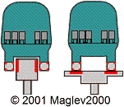 |  | Planar Mode is shown in the illustration on the left. Powell-Danby MagLev vehicles can ride either on a monorail guideway, or in a “double-rail” planar configuration, the latter supporting easy, instantaneous switching between rails. Ctrl-click on the picture to learn more. This allows individual vehicles to be switched off onto other guideways, or onto sidings. The same strong superconducting magnetic fields that levitate the vehicle also stabilize it in the double-rail configuration.
(5) Planar mode for Mass-Transit: This can also be used for mass-transit, replacing existing subways and commuter rail, in place. Compared with a conventional electric steel-wheel on steel-rail system with regenerative braking, this is not that much more energy-efficient, but it is (a) capable of higher speed (up to 150 mph or so), (b) much smoother and quieter, (c) does not produce steel dust and its deleterious health effects, and (d) operations and maintenance costs for MagLev would be no more than one-third that of steel wheels, enabling huge life-cycle savings.
(6) Planar Mode on Roads: In the same way, planar mode can also be combined with regular roads. This means that MagLev vehicles can also share lanes on bridges and tunnels.
(7) “Snap-together” construction: Whereas most rail and highway construction is done in-place, which is expensive, most of the components of the MagLev system can be pre-fabricated in factories, and trucked to the construction site, where they are assembled into a completed guideway, which is considerably cheaper and faster; and also avoids the pitfalls of in situ construction. ^{[6]}
(8) Bundling: A big thing nowadays is “bundling” of construction projects. ^{[14]} Powell/Danby MagLev, by the very nature of its prefabricated construction, is bundled, which is a big selling point.
(9) Narrow Monorail: Except for switches, most of the guideway is 5’-wide (~150cm) monorail. It is less expensive than the massive trough (Japanese) or Transrapid (German) guideways. It is lighter, and easier to build on pylons above ground. Also, it also does not block out the sun, which is especially important if the guideway is above farmland. Because it is on pylons, it is easier to avoid disrupting underground utilities.
(10) Lighter Guideways: Note that, because of the unpredictability of loading factors, highways and conventional railroads have to be overbuilt. In both cases, the gross weight of the vehicle is concentrated in the wheels, and then applied to the rail or roadbed. In 2G SC MagLev, the weight is more predictable, and is spread out along the length of each vehicle, so that lighter guideways can be used or, alternately, a bigger margin of safety can be applied.
(11) Bridges and Tunnels: When crossing water, one might install a planar MagLev system over existing rails in a facility such as a bridge or tunnel, or alternately embed a planar system in a paved roadbed within said facility. This incurs some additional costs, and also run slower than pure MagLev. It also might mean that fewer conventional vehicles could use the facility, and one would have to evaluate whether the MagLev system would “displace” as many vehicles equivalent to the reduced capacity of the facility.
(12) New Bridges: Once the 2G SC MagLev is mature, it is probably worth considering building a new MagLev monorail bridge in addition to the existing infrastructure. It can be cheaper, and the MagLev vehicles could travel at full speed.
(13) Weatherproof: The stability provided by the Electro-dynamic Stabilization means that the vehicles will cling to the monorail with a force that can withstand the severest hurricanes, but probably not tornadoes. Thus, severe weather that forces aircraft to be grounded, and prevents also cars, trucks, and trains from moving, cannot stop MagLev. Also, because MagLev is on elevated guideways, it is more useful for storm and flood evacuation than current transportation technology. Just remember that the MagLev infrastructure itself has to be stormproof, that is, it has to withstand those severe hurricanes.
(14) Simplicity: Some people say that MagLev is too complicated. Actually, it is far simpler than current vehicles. First of all, each MagLev vehicle is basically a box with magnets along the bottom. All control is exercised by the guideway. The “box” just passively rides along. ^{[5]}
Also, the configuration of the overlapping loops in the guideway (either monorail or planar), although it may look a bit complicated, is actually much simpler than current internal-combustion engines, or jet engines, which have thousands of parts. All these parts wear out, creating the need for maintenance. MagLev should have close-to-zero maintenance.
(15) Prior Art: About twenty years ago, when there was renewed interest in MagLev, Powell, Danby, and their associates invented Second-Generation (2G) MagLev, as recounted above. They also built all the components of a 2G system, and did it on a $5 million shoestring budget. They built a short test track. They have verified much of the system based on these limited resources. Also, the 1G system is enough like the 2G system, such that the success of the 1G system can be applied to the 2G system for straight-line operation. What is yet to be tested is running the system on a long test track, with electromagnetic switches, not heavy, cumbersome mechanical switches.
(16) No preemption: One of the current problems with passenger rail is that, very often, it runs on rails leased from freight railroads, and the freight has priority. With a MagLev system, all vehicles, passenger or freight, have to go at the same speed on the same guideway, so there is no preemption. It would be wise to have separate depots for passengers and for freight, but everybody uses the same MagLev network. ^{[10]}
(17) Safety: The current road system is expensive and dangerous. The number of traffic deaths is still too high, despite the fact that deaths per passenger mile have gone down over the last century. Truck accidents take a particularly heavy toll per mile, and are more likely to cause fatal injuries, as well as block off major arterial roadways. Do not think that self-driving trucks will be a total panacea.
(18) Greenness: The current system is also unhealthy, causing respiratory disease (due to microparticulates, carbon monoxide, and unburned fuel) and global warming. MagLev uses less energy, and the energy it uses is electricity, which can be very clean, if properly sourced. Also, using electricity used to mean less importing of foreign oil, and nowadays means less need for fracking, which pollutes the environment and causes earthquakes.
(19) Low Cost: It costs $3,500 to ship one truckload of freight from coast to coast, and that is just for the fuel and tolls. This does not include the driver’s pay, and the wear-and-tear and depreciation of the vehicle. In contrast, the MagLev system can send two truckloads, coast to coast, for $1,100 worth of electricity. ^{[12]}
These figures do not include the wear-and-tear on the roadbeds (the heavier the truck, the more damage), and the inconsequential wear-and-tear on the MagLev guideway, nor the net tolls (not including the electricity) on the MagLev guideway, which should be much lower than for an asphalt highway.
Also, even though the cost of high-temperature (liquid-nitrogen temps) superconductors started high, it is going down, and will be significantly cheaper in the future.
(20) No trains: Until recently, it was most efficient for railroads to have long trains. This minimized the crew needs and simplified scheduling. This is no longer true for MagLev, which can be done with a robotic system on an exclusive guideway, using individually-targeted smaller vehicles, no more than about 80 feet (25 m) long. This gives you a lot more flexibility, both regarding scheduling and switching. If there are segments that overlap conventional rail, or roads, an automatic system supplemented by remote human “drivers” can work and be safe.
(21) International Trade: On the world marketplace, this could be a major rival to China’s Belt and Road Initiative. ^{[3]} It is a far-superior system anyway. This will help our national prestige, and our trade balance.
(22) Pipelines: Water Train ^{[2]} is a replacement for pipelines, and it is safer, faster, more secure, and less prone to leaks.
(23) Standard Gauge: Because the implementation of this MagLev system is just starting, it is important to have a standard for the MagLev guideways that can endure a long time, perhaps even 200 years. Conventional railroads operate on the Stephenson or Standard Gauge of 4’8½”, even though the Brunel Gauge or 7’¼” might have provided more stability and prevented a lot of derailments over the centuries.
The “standard” applies not only to the dimension of the rail, but also the coils inside the rail, and the fields they generate. This is analogous to the world of cell phones. They may look alike and operate in similar ways, but the phones have to be compatible with the networks. The mobile carrier Sprint had once merged with NexTel, in order to better compete with the “big boys”. However, their systems were incompatible, the merged company ended up only a little bigger than Sprint was before the merger. Later, Sprint adopted the wrong 4G standard. Recently, they had to merge with T-Mobile just to survive. ^{[15]}
Item (9), above, indicates the MagLev monorail should be five feet (1524 mm) wide, about half of the total width of the vehicle. This is similar to the outside gauge (5’1½”) of the Standard Gauge railroad (allowing 2½” per rail), which, as just noted, is not as stable as one might want. However, the MagLev monorail provides two electromagnetic forms of stability, that conventional rail cannot.
Further Advantages:
(24) Better than Self-driving Cars and Trucks: These will only add to the congestion of our already-overcrowded streets and highways. This MagLev system, with all its vehicles on centrally-controlled guideways, operating at higher speeds, will have a higher density of vehicles without any danger. Other, more-conventional vehicles would continue to operate on conventional streets and highways, which should be far less crowded than before.
(25) Very-Large Objects: There was an extremely large scientific instrument (probably a particle detector for CERN) and it was very difficult delivering it overland. If one could build two parallel MagLev elevated guideways, one could transport such an extremely large object. The speed would be slow, far less than the 300 mph of which MagLev is capable, but still much faster than can be done otherwise. Once it this exceptional cargo is delivered, the twin MagLev monorails can become part of a MagLev network, or be salvaged and used as part of another such network elsewhere.
Advantages discussed in later sections of this paper:
(26) Time Saving: We waste a lot of time in travel. By emphasizing door-to-door speed and minimizing the number of vehicle changes, each trip is easier, more convenient, and takes less time.
(27) No “Transportation Hubs”: These exist in order to allow passengers or freight to conveniently transfer from one train, or mode, to another. These are potential chokepoints. Using the hexOgrid, as described below, they are completely unnecessary.

Summary
Powell’s and Danby’s 2G SC MagLev is superior to their previous 1G MagLev, and far superior to the conventional systems (both road and rail) we have now.

II. How to Design and Build a MagLev Network
Whereas Hyperloop is described as being a system whose initial specification should be very similar to the final product, the MagLev SuperTurnpike is described as a system subject to “Long-Term Evolution”. That is, it will start small, and evolve into a multi-trillion-dollar transcontinental system. It does not have to be built all at once. Each stage will provide useful service, and also build upon the previous stages.
First of all, you will need to build an “Alpha” test track. It would probably be in a rural area, with some wilderness nearby. Mockups of urban areas can be built. This way, we can see how the MagLev system interacts with all three – wilderness, farms, and densely-packed urban areas.
Another important question relates to whether the freight system, or passenger system, or both, should be developed first. Freight-first has several advantages. Passenger-rail services, including previous MagLev systems, invariably lose money, and often have to be bailed out with public money. However, a working passenger system is more likely to get people interested in MagLev. Freight tends to make money. By this token, developing a freight system first means that you can plow back the profits from the freight system into the passenger system. Also, in a freight system with no passengers, you can more easily test safety systems that eventually can incorporated into the passenger system.
Profits from the freight system could be directly used in further developing the MagLev system, or be used to attract investment, either bonds or equity.
Another important question, concerning freight, is whether to use a Ro-Ro (“Roll-on/Roll-off”) system, in which an entire tractor-trailer rig is rolled onto a MagLev container, and at the other end of its MagLev journey, rolled off and then driven the rest of the way; or the “RoboTrail” system, where a streamlined container rides to a MagLev depot on a flatbed trailer, and then is lifted onto a MagLev bogie (undercarriage) that rides the guideway to another depot, where the process is reversed, and it continues on to its final destination. Ro-Ro requires the heavy truck-tractor and its driver to travel the whole way, while RoboTrail transports the goods in a lighter-weight container, making it more efficient.
For the beta test for freight, one can build a lower-speed intra-urban system as a proof of concept.

High-Throughput End-Loading Passenger Transport
[This section is Patent-Pending (Pat.-Pend.)]
This section describes a novel form of transport that could be the beta test for a passenger system. It does move passengers in a useful manner. This is a shuttle system to move large numbers of people between two close-by places. An example would be between an existing rail station, and a sports venue, such as between the Frank Lautenberg station in northern New Jersey, and the nearby (7-mi.) Meadowlands Complex. In fact, this whole section was inspired by a New Jersey Transit Request for Proposals for just such a system. Some of its unusual features can be incorporated into the final system.

Developing a MagLev passenger service early on is more likely to “capture the public’s imagination”, which should not be underestimated as a selling point, even though “freight-first” is still better from technical and financial points-of-view.
A. Embarking and Disembarking (Pat.-Pend.)
Instead of trains, there will be many driverless passenger vehicles, of various sizes, each traveling between one area and the other, without turning around.
Using individual end-loaded cars means that passengers can expeditiously board the car, and just as expeditiously leave the car at the other end. Since it is such a short trip, the passengers would enter at the “rear”, and start taking their seats in the "front", with the last passengers sitting in the "rear". Disembarking, the "front" passengers would leave first, from the “front” door. Of course, when the passenger vehicle is going in the opposite direction, "front" and "rear" are interchanged.
Because there are so many more vehicles than there would be if you were using long trains (counting each train as one vehicle), the passenger vehicles can be available with much shorter wait times, perhaps only a couple of minutes.

B. Emergency Exits (Pat.-Pend.)

In a long train, in case of an emergency evacuation, it is often impractical to have passengers exit by the end-doors of each car, as that would entail walking through the entire rest of the train. Therefore, each car has multiple windows that can be easily removed in case of an emergency.

Since each car in this system travels by itself, the end doors (front and back) would often be sufficient to allow all passengers to exit for smaller passenger vehicles. They would exit to the tracks. MagLev does not need energized high-voltage rails (third rails). Any electricity in the guideways is sealed off from the outside world, and cannot harm anyone who might walk on the guideway. For larger vehicles, you may want to have some of the windows be available as emergency exits.

In a monorail, there is a problem with using windows as emergency exits, in that, if the car is stopped, there will be nothing immediately below the windows for passengers to set foot on. You might have specialized rescue trucks to raise a platform to right below the emergency-exit windows. Also, you could have a double outside wall below such windows, with one part on hinges, so it can swing up, providing a platform for exiting passengers. These would only be used if there is an emergency, and the car is stopped.

C. Terminal Areas, Depots, and Gates (Pat.-Pend.)
Each car travels from one Terminal Area to the opposite Terminal Area. It might be possible in the future to have systems with more than two Terminal Areas, but each passenger car would travel only between one Terminal Area and some other Terminal Area, with no intermediate stops.

Each Terminal Area would have one or more Depots. A complicated multi-level rail station might have one for each level. You might also want to have some for outlying parking lots.

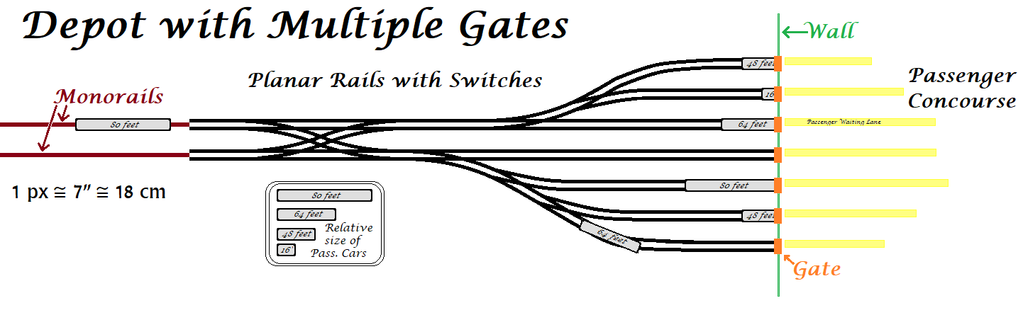
Each Depot will have one or more Gates, each servicing one passenger car at a time. The main guideway into the Depot will fan out to the several Gates. The vehicles can be of various sizes (lengths), depending on the momentary needs to transport people.

The figure, above, shows the structure of a Depot with seven Gates, connected to two MagLev monorails, and accommodating different-length passenger cars.
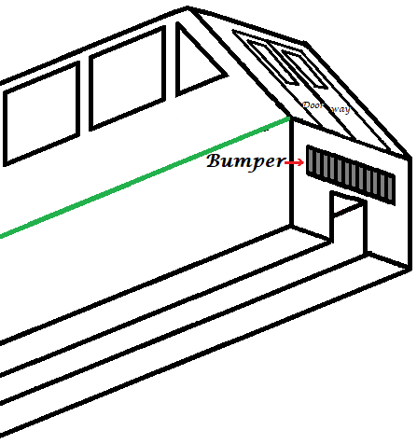
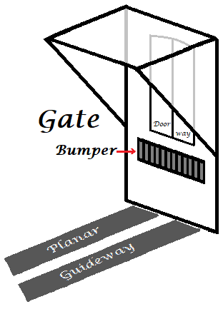
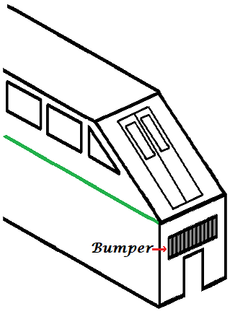

The figure on the left shows the topside of a MagLev passenger car. The figure on the right shows the underside of a MagLev passenger car. The figure in the middle shows the Gate that it fits into. The passenger car can operate on either a planar guideway, or on a monorail. Only the planar guideway is used in the immediate Depot area. [These three figures are not Pat.-Pend.]

Each Gate will be a closeable doorway in a wall separating the platform from the guideways. That is to prevent passengers from wandering onto or, worse yet, falling onto, the guideways.

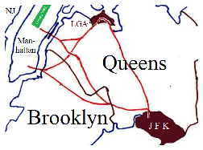
It is possible to implement this system on a larger scale. The map, to the right, shows a suggested system to serve two of New York City’s three major airports, plus Manhattan. The guideways are in red. The three terminal areas are each of the two airports, plus Manhattan. Manhattan has two Depots, one Downtown, and one Midtown, that are not close to each other. You cannot use this system to get from one to the other directly, but there are plenty of alternatives.

When developing such a system, the alpha test track should progress from a simple guideway with two Gates, one on each end, and progress to have multiple (perhaps three) Gates in at least one Depot, to having multiple Depots (again, perhaps three), and so forth.

In the final system, if a passenger vehicle has to make an intermediate stop, it has to leave the main guideway, so it doesn’t matter if it turns around. Therefore, this system of Depots and Gates can have general application in a MagLev system.

Once the initial operational systems are in place and earning money, some of that money can be plowed back into building the next stage. Also, when people perceive that MagLev works, then they might be willing to invest in it, and build a full-speed (300-350 mph) test track, and then a full-scale system.

Earlier versions would resemble conventional rail, following fixed routes, usually alongside existing highways, particularly Interstate Highways. ^{[16]} Instead of stations, they would have offline depots, as explained below. The through traffic never leaves the main line. Once this is proven, other guideways can be added, forming a true MagLev Turnpike that will evolve into a SuperTurnpike.

III. What Constitutes a MagLev Turnpike
The difference between MagLev, and a MagLev Turnpike, is not so much the MagLev technology, but the way it is used.
For a MagLev Turnpike, any vehicle, within a certain size range, can be put on a MagLev network. Rarely would it already have a MagLev undercarriage – that would be provided by a separate bogie (undercarriage) that is bolted to the vehicle, or by a streamlined container.
The “tolls” for this turnpike would depend only on a few straightforward factors, including the vehicle size, whether it is passenger or freight, its priority, or any special considerations. The rental for the bogie or the container would be added to the toll.
The original concept, from 2003 and first published in 2004 ^{[17]}, is LeviCar, ^{[18]} a modular car with a detachable road chassis. It can be driven to a MagLev depot, where the car body, with the passengers and luggage, is removed from the road chassis, and placed on a MagLev bogie, and sent at 300 mph on the MagLev network to another depot. There it is removed from the MagLev bogie, and placed on another road chassis, and driven off to its final destination. If the road chassis are leased, that makes the financial arrangements more straightforward. The road chassis from the destination depot is simply that from another LeviCar that started its MagLev journey at that depot.
Expanding the concept to include trucks and truck trailers, makes this a MagLev Turnpike.
The depots are on sidings from the main MagLev lines. The vehicles on the main lines never stop, until they get off the main line, onto a siding, and finally to a depot. It is important to note that these are not “stations”, where the whole train is stationary, but rather “depots”, where a vehicle or freight container is either deposited on the MagLev Guideway, or taken off the guideway and deposited on a road chassis or flatbed truck, or, in the case of RoRo (“Roll-on Roll-off”) trucks, simply driven out of the container and driven away.
However, there may be mass-transit vehicles that never go on regular roads, that is, they never leave the MagLev system. They can range in size from small pods (two to four passengers) up to “buses” (80 passengers). The smaller ones can have doors on the side, while the long ones might can either have doors on the side (like subway and commuter-rail cars), or on the end, as discussed above, with passengers entering and leaving through only one end at a time. (Such doors would have to be sloped, to provide aerodynamic streamlining to the ends of the vehicles.) This saves some space in the middle of the cars, where the doorways would otherwise be.
The vehicles equipped with such doors, can leave the main MagLev line, and each travel on a spur line to a “Gate”, which is a closeable doorway in a wall separating the passenger concourse from the tracks. That is to prevent passengers from falling or wandering onto the guideways. One end of the passenger vehicle will automatically stop at the Gate, some passengers will get off, others will get on. The passenger vehicle will then reverse direction, and return to the main MagLev line. The spur line can be short or long, as needed. See High-Throughput End-Loading Passenger Transport within Section II, above.

Why MagLev is Better than Hyperloop
For the past few years, there has been a considerable amount of “hype” over Elon Musk’s proposed Hyperloop ^{[19]} mass-transit system. Many see it as a rival to California’s High-Speed Rail (HSR) ^{[20]} proposal. Unfortunately, both Mr. Musk and the California HSR people overlook one important thing: What is the door-to-door speed of the trip? Consider a typical inter-city trip: You might drive the whole way, but then you would face traffic, tolls, large trucks, limited speed, and fatigue, and the possibility of an accident. However, you do have the convenience of a single-vehicle trip.
Or, you might choose to use some form of mass transit, such as plane, train, or bus. You will probably need to use some form of mechanized transport just to get to the station or airport, such as driving there and parking, or have a friend drive you there, or use commuter rail, local bus, cab, Über, Lyft, or a “limo”. At the “destination” station or airport you will need a similar service to get you to your final destination. The point is, just minimizing the travel time between some point-A and point-B is not good enough. Let us change our terminology a bit to put things more in perspective. The trip would be from point-A to point-D, while the possibly-high-speed segment would be from point-B to point-C. In addition to maximizing the speed from B to C, we also want to minimize the time from A to B and from C to D.

Direct Destinations

for passenger vehicles:
In many cases the link from C to D might not be necessary. Suppose you are visiting a historic city. Once there, you plan to get around by walking, buses, subways, and taxis. It would be possible to have a MagLev or other line go directly to your hotel, where you would unpack. Your vehicle would then be automatically driven to a secure parking facility. At the end of your stay, it would be automatically conveyed right to the hotel lobby, where you could repack and go on your way. Alternately, the hotel could be built with special conveyors and elevators so that your car could stay right in your hotel suite, but that would be expensive.
Hospitals could have direct MagLev lines to their emergency rooms. If any passenger becomes ill on a trip, the vehicle could be redirected to the quickest available hospital, without waiting for the trip to be completed, as with Hyperloop.

for freight:
The freight version of LeviCar is called RoboTrail. It would be possible to have MagLev and other lines go directly to warehouses, without having to carry the freight from the depot to the warehouse on the back of a flatbed truck. Likewise for factories and shopping malls. Each could have conveyor systems (in the basement, for shopping malls) to take items from the MagLev portal to their individual destinations (individual stores, for a shopping mall). In fact, it could be possible for freight to travel almost completely by MagLev, except for the last leg when the destination is not big enough to justify the expense of such a portal.
What about the stores and other freight destinations in the historic center of an old city? You can’t go ripping up everything to install MagLev depots, which many locals might consider to be unsightly. It would be best to position the MagLev depots right outside the historic district, and to use only smaller standard freight containers, such as 20-footers. Each depot would have a fleet of electric flatbed trucks to take the freight the final mile or two. Also, the drivers of these trucks would be totally familiar with the area, or autonomous vehicles would be used.

The hexOgrid Network

Introduction
One of the main purposes of hexOgrid ^{[21]} is to put guideways close to anyone who may want to use them — to minimize the distance between A and B, and, symmetrically, between C and D. Let us face it, we will not have a transit system (other than good-old-fashioned roads) that permeates down to each individual driveway. But, if we can have a system so that you do not have to travel more than ten miles (16 km) by road, to your nearest depot, then the A-B and C-D distances will be minimal. This is done by having parallel guideways close together, about eighteen miles (29 km) apart. Having many guideways going in the same direction provides redundancy, so if one guideway is out due to weather, accident, or sabotage, the network can still function. The hexagrammoid shape of the grid is also designed to give a smooth ride by limiting the acceleration (g-force) that the passengers feel when the vehicle changes direction.

Rationale for hexOgrid
The overall shape of the hexOgrid was determined by several needs, including (1) having depots within ten miles by road from any point in urban or suburban (built-up) areas; (3) limiting g-forces during acceleration and switching to tolerable levels; and (4) providing redundancy so that loss of one guideway will still leave a functional network. By having the guideways change direction by 60° rather than 90°, the time and distance spent at each junction is lessened.
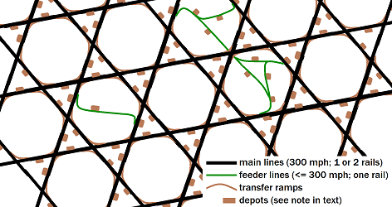
After reviewing RoboTrail and LeviCar, for which hexOgrid was designed, a railroad man commented that hexOgrid can also be used for conventional rails. It is also possible that it may also have application to highways, conveyor systems, and urban planning. The major difference will be that, with vehicles running at different (usually lower speeds), the sizes of the grid will be different, in proportion.The diagram to the right shows an idealized “Exemplary Grid” that could cover a geographic area with overlapping hexagrams. In additional to the main guideways (heavy black), there are transfer ramps (brown) to go from one guideway to another, and feeder lines (green) to provide access to areas off of the main grid. The main lines will carry vehicles at 300 mph, while the feeder lines might operate at lower speeds. Also, there are sidings that lead to depots.
Note: The small scale of the maps precludes detailed representation of the depots. They actually involve acceleration/deceleration ramps and several facilities for transferring vehicles. Depots are located on one side of the guideway or the other, and are so pictured. Whichever side that they are on, they service vehicles heading in both directions. In its actual implementation, hexOgrid will probably not be an exact hexagrammoid grid, as depicted above, but will be adjusted to meet local needs, including topography, environmental impacts, local laws, availability of rights-of-way, and other legal considerations. The map on the next page depicts a representation of how such a practical grid might look for the State of New Jersey. Notice that the grid is not set up to facilitate travel within the State, but is mostly for travel into, out of, and across the State. (A variant MagLev configuration can handle transferring tons of passengers short distances, such as between an existing rail station, and a sports venue or shopping mall, as discussed above.) Also notice the “wormhole” going from the Pine Barrens of southern New Jersey towards the First Coast area of Florida near Jacksonville. This will provide super-fast passenger transport for snowbirds to get to warmer climes.
Combining the MagLev Turnpike with hexOgrid gives you the MagLev SuperTurnpike.
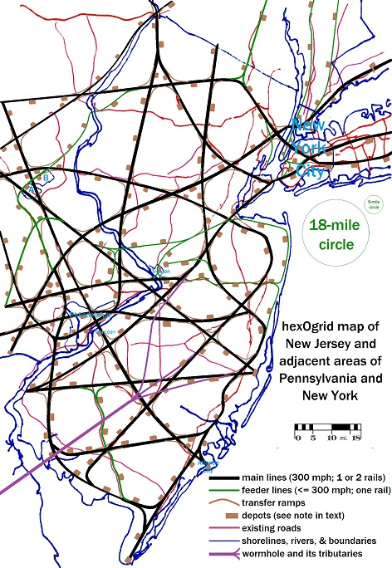
Ramps, Sidings, and Feeders:
The heart of hexOgrid is the ability to easily switch guideways to change the direction of travel. For MagLev guideways, this can be done only by using the Powell-Danby architecture, which permits near-instantaneous switching without slowing down, because it’s all done with magnets. As discussed above, road vehicles can switch very fast, without breaking stride, but at a lower speed than MagLev. Conventional railroads can switch fairly fast, but usually have to slow down.
The hexagrammoid grid is mostly for through traffic, and has ramps to switch from one direction to another, ideally changing direction by 60°, but not slowing down. Centripetal acceleration (g) forces are kept to within a tolerable range, perhaps 1.2 g total (Pythagorean sum with natural gravity), and the ramps are appropriately banked to minimize discomfort.
There are also sidings that come off of the main grid and go to depots, or directly to hotels, resorts, hospitals, shopping malls, factories, or warehouses (see discussion above). These are specially designed to decelerate vehicles from full speed on the main guideway, to a standstill at the depot or the “direct destination”, and likewise to accelerate the vehicles going towards the main guideway. The vehicles that are not going to the depot stay on the main guideway and do not slow down.
In congested areas, you would want to have the distance to the nearest depot to be less than the ten-mile standard. Feeder guideways come off from the main guideways, and have several sidings coming off of them, and then rejoin the main guideway grid somewhere else. These might operate at speeds slower than the standard 300 mph, and can more easily follow existing rights-of-way.
Lastly, there is a big difference between travel on the main guideways, and on the other guideways. Travel on the main guideway is fast, continuous, and regular. Travel on the others might be at a slower speed, might involve acceleration or deceleration, might have vehicles entering and leaving the guideway at irregular intervals, and might have vehicles traveling in one direction at some times, and the opposite direction at other times. [Because of the Linear Synchronous Motor (LSM), they cannot collide.] To smooth over the transition from one guideway to another, the main guideways might have parallel sidetracks, such that a vehicle will go onto a sidetrack before going on a ramp, siding, or feeder; or likewise go from a ramp, siding, or feeder onto a sidetrack before entering the main guideway. Notice that feeders might also have sidetracks of their own to transition to their own sidings. Also, the addition of sidetracks would affect the per-mile cost of the guideway. A single track with a sidetrack would cost more than a single track alone, but might substitute for having a two-way pair of tracks. A two-way pair with one sidetrack would cost more than a two-way pair of tracks alone. These additional costs are justified by making the system much more useful.
Note that, for elevated MagLev guideways, it is desirable to build them over existing rights-of-way in built-up areas, and that means that in some places, you cannot really use the idealized hexagrammoid grid. In rural and wilderness areas, you have more freedom to place the main guideways according to the idealized grid.

Ramp Arc
When making the 60° turn between guideways of the main network, the g-forces on the vehicles will rise and fall, potentially discomforting the passengers. The turn ramp will be banked, so that the g-vector will point downwards, even as the g-forces change.
If the ramp is a circular arc, then the g-force will jump at the beginning of the arc, and equally fall at the end of the arc. Also, there will be a brief segment where the vehicle is not banked, resulting in some sideways acceleration. Instead, the ramp has to be a more complicated curve, with the total g-force (Pythagorean sum) slowly rising to its maximum value (presumably 1.2 g) and then falling again to the baseline 1 g. The curvature of the arc will start small (large radius-of-curvature), increase until the middle of the arc (smaller radius-of-curvature), and then taper off again. The banking of the guideway will also change as the curvature does. The details of this curve will be determined later.
The ramp arc can also be used between straight segments of feeder lines.
It might be necessary to have some sort of passenger-warning signal for when the vehicle is about to enter any curved section. Even though we attempt to manage the g-forces through curves, they still might be disconcerting to passengers.
Acquisition of Right-of-Way
A big problem in establishing a new transportation system is acquiring the land on which to place it. Using eminent domain might well be justified because this will not be a regular railroad which would only be used by vehicles from the company that owns the guideway, but rather a kind of turnpike that would be open to all compatible vehicles – although most current vehicles would need to either be bolted to a MagLev bogie, or put into a MagLev container.
Because almost all of the guideway will be on elevated pylons, there can be minimal impact on infrastructure already on (or under) the ground.
Notice that any other ground-based system, including HSR and Hyperloop, would have the same problem.

Hills [This section is Patent-Pending (Pat.-Pend.)]
MagLev is capable of handling high gradients, more than the standard 3% of the Pennsylvania Turnpike, and certainly a lot more than the gentle grades of conventional rail. Cresting a hill at high speed can result in lowered g-force, giving passengers an unpleasant sensation. It is unlikely that it will ever be a zero- or negative- gravity situation, but even momentary reduced gravity can be unpleasant. The proposed solution is to have the track curve as it is cresting a hill, so that the negative effect on the perceived gravity can be counteracted by the positive increase in g-force due to centripetal force. The track is banked, as in the example above, so that the gravitational vector always points down. If there are no noticeable sudden changes in g-force, no passenger alarm is needed.
Going through a valley can result in increased g-forces, but, since the MagLev track is elevated on pylons, it can simply be built to be elevated more in the valley, with a greater radius-of-curvature, minimizing the g-forces.
The guideways will have to be carefully designed to minimize these vertical g-forces to avoid the “elevator” or “roller-coaster” effect. Notice that any other high-speed ground-based system, such as Hyperloop or ET3, would have the same problem.

IV. Speculative Enhancements

Higher-Speed Segments [This section is Patent-Pending (Pat.-Pend.)]
After the initial hexOgrid is built, it can be supplemented with some different higher-speed (and higher-cost) mode. The standard-speed mode might be MagLev (300 mph / ~500 kph); and the higher-speed mode might be something like a Vactrain ^{[22]} (2000-mph / ~3000-kph), or somewhat-slower-speed soft-sided transportation tubes (see the Appendix, below). A vehicle enters the network at a standard-speed depot, travels a while on the standard-speed network (300-mph for MagLev), is then switched to the higher-speed mode without stopping, and is later switched back to the standard-speed network, finally coming to a stop at a standard-speed depot. It is also possible that the trip might be in five (or seven or nine) alternating segments of standard-speed and higher-speed conduits.
This means that the vehicle must be compatible with both the standard-speed and higher-speed conduits. If the bottom of the vehicle is built to ride on a Powell-Danby MagLev guideway, then such a guideway probably has to be incorporated into the higher-speed transportation tube. If a vehicle needs to have some sort of a protective dome or fairing (to manage air resistance at the higher speed, or to keep the air in while traveling in an evacuated tube), such accoutrements have to be on the vehicle the entire trip, both on the standard-speed and higher-speed modes. The MagLev undercarriage and dome, fairing or container can be applied as the vehicle enters the standard-speed network for the first time, and removed when it leaves it for the last time.
The higher-speed segments might be hard-sided, like traditional VacTrains like ET3 and Hyperloop, or they may be soft-sided, like what is being proposed below.

hexOgrid+plus (Pat.-Pend.)
Suppose this higher-speed mode is switchable — that is, it can be easily switched from one guideway or tube to another. Then it is possible to overlay a larger hexOgrid on top of the standard hexOgrid. The larger, higher-speed network has many of the same advantages of the smaller, standard-speed hexOgrid, except that it does not have to provide depots close to any point — just provide access to the standard network.

Wormholes (Pat.-Pend.)
Now, suppose this higher-speed mode is not switchable — that is, it cannot switch from one guideway or tube to another. In this case, one could have straight shortcut “transportation tubes” between one part of the network, and another part far away. I propose calling such a shortcut tube a “wormhole”, after the popular name for an Einstein–Rosen bridge, ^{[23]} as mentioned in Carl Sagan’s Contact and in Star Trek, Deep Space Nine. ^{[24]}
Sadly, it is likely that hard-sided transportation tubes, including Hyperloop, are not switchable, as discussed in my critique of Hyperloop. ^{[25]} Therefore, wormholes might be essential if you need super-fast transportation.
However, this paper describes an alternative to Hyperloop, ET3, and other VacTrains. This is called “Soft-Sided Transportation Tubes” (SSTTs), and has vehicles travel on MagLev guideways, within partially-evacuated tubes that have soft, not hard, sides, and may also be switchable. Because of the extremely speculative nature of this concept, it is described separately in the Appendix below.
The Appendix also discusses how SSTTs could be used for two very important issues with hard-sided tubes: (1) Switching, and (2) Entering and leaving the tubes at the end.
Is is this author’s strong opinion that it is too early to spend a lot of money researching transportation tubes in general. Discussing these now is like discussing SSTs (Super-Sonic Transport planes) in the 1960s – it is too early. There were three proposed SSTs that were first discussed in the 1950s and 1960s, and eventually built, if only as prototypes. The Concorde had sky-high cost overruns (by a factor of 18, nearly £1.3 billion), with $8,000 round-trip transatlantic fares; the other two SSTs were cancelled (American Boeing 2707) or had very limited service (Russian Tu-144).
Besides which, we should first find out how safely and cost effectively the MagLev [Super]Turnpike will work, and save transportation tubes for later. Perhaps we will decide that we do not need anything faster than MagLev.

Permanent MagLev Undercarriages for Cars
[This section is Patent-Pending (Pat.-Pend.)]
If the cost of high-temperature superconductors continues to go down, the cost of MagLev undercarriages for cars (“MagLev Bogies”) might reach a point where its price might be reasonable, say $8,000 or less. Then, it might be possible to permanently affix such bogies to cars. The same is true if lower-cost super-strong permanent magnets are developed.
A car that is so equipped could drive on a regular road, and then enter a road that has MagLev loops incorporated into the pavement. After being told where the car is headed to, an automatic mechanism can direct it to MagLev-only Lanes, which can take the car to near its final destination at 150 mph, without the hassle of disassembling and reassembling the car. If the driver is awake, or if self-driving is perfected, the car can drive the last few miles to its final destination.

V. Conclusions
An architecture of transportation conduits is described that can provide close-by service for both passengers and freight, with comfort for passengers, and redundancy to enhance reliability. It was originally designed for 300-mph Magnetic-Levitation (MagLev) guideway, but can be used with other systems. It forms the basis for the LeviCar / RoboTrail system.
It is safer, cleaner, and more sustainable than the current transportation systems, and also than the many proposed alternate systems, such as Hyperloop.
It is dedicated to the concept that it is more useful to provide shorter door-to-door transit times to most people, than to provide really fast transportation between select cities. Also, by being so versatile and usable for all kinds of passenger transport and most kinds of freight, there should be a lot of mileage revenue that can easily amortize the construction costs.

Appendix: Soft-Sided Transportation Tubes (SSTTs)
[This appendix, included all its figures, is Patent-Pending (Pat.-Pend.)]
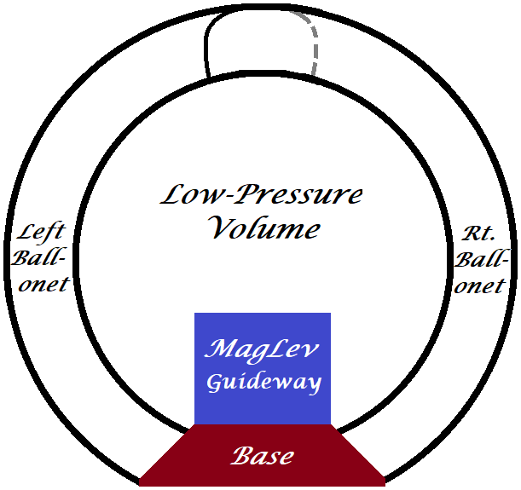
The contents of this section are extremely speculative, so it has been made into an Appendix to the main paper. The author is not even sure what materials can be used to build this.

There has been a lot of “hype” about Elon Musk's proposed Hyperloop partially-evacuated Transportation Tube, although there have been earlier proposals, such as ET3.

Here is yet another proposed Transportation Tube. Instead of having hard sides, like Hyperloop and ET3, it has soft sides. You may object to this idea, and I admit that it is very primitive. At the end of the previous section (“Wormholes”), I suggest we work out the MagLev SuperTurnpike first, and then see if Transportation Tubes are really necessary. If that is the case, we have twenty to forty years to refine the SSTTs.

An SSTT would be a double tube, with smaller airbags, called ballonets, in between. The outer tube could face the outside atmosphere (or be encased in a lightweight protective shell), and the inner tube would enclose a partially-evacuated chamber in which the vehicle rides. It would be attached, at the bottom, to the base of a MagLev guideway. It would be surrounded by ballonets (pronounce that as in English, not French, even though they were a French invention). The inner and outer tubes, and the ballonets, would be anchored to the base. Each ballonet would be a banana-shaped bag, between the two tubes, and firmly attached to the inner tube. There would be many ballonets along the length of the tube, one on each side for every 20-40 inches. Each would be inflated from pipes in the base of the MagLev guideway. As the ballonets are inflated, they will pull the inner tube into a shape with a circular cross-section, but with very little air inside, thus creating a partial vacuum for the vehicles to travel in. They would simultaneously inflate the outer tube into a circular cross section. Having many ballonets means that, even if some of them leak or otherwise fail, the system as a whole will still work. (Originally, “ballonets” were “balloons within a balloon” and used to control the buoyancy of a balloon or of an airship.)
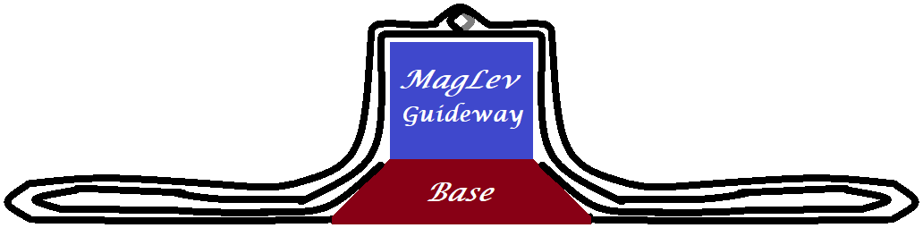
Bear in mind that this arrangement might be somewhat leaky. One might have to run pumps to keep the ballonets inflated, and also run suction pumps to maintain the near-vacuum of the inner tube. The air sucked out of the inner tube can be used, with ambient air, to inflate the ballonets. If the air in the ballonets is released, the outside air pressure should collapse the tube, as shown immediately above.

If the ambient air pressure is not enough to collapse the tubes, additional ballonets can be added above the original ballonets, such that inflating these “crusher” ballonets will forcibly deflate original ballonets, and the inner tube.

Collapsing the inner tube can be an effective way to close off a tube for (1) switching, because its guideway is not currently in use, (2) in an emergency, or (3) at the ends of the tube. In the last case, the tube can be open to accept or expel a vehicle.
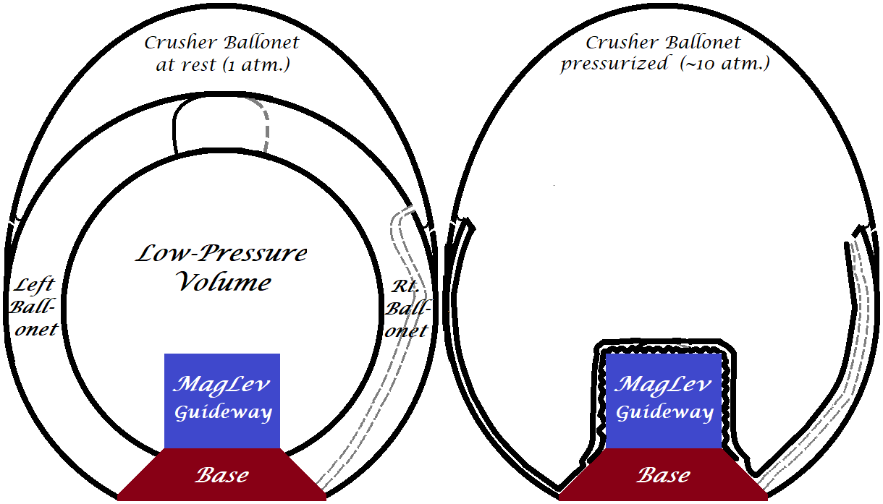

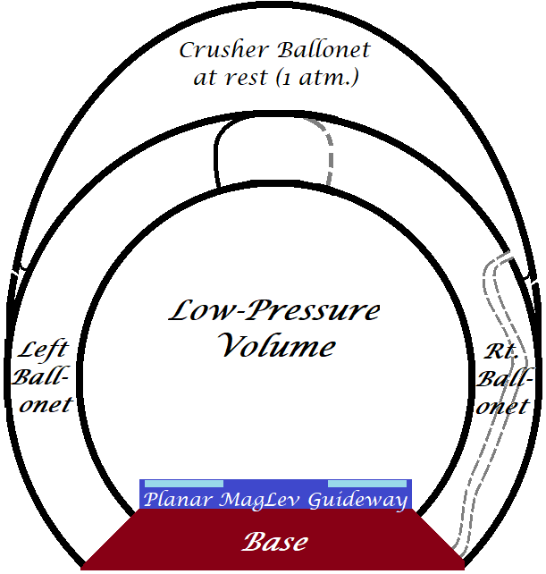
Switching (Pat.-Pend.)
We have seen before what a Powell/Danby MagLev Switch looks like ^{[7]}. This would use the same switching mechanism, but covered by SSTTs. Instead of a monorail, the MagLev guideway is in planar format, with two parallel rails. In cross-section, it looks like the diagram on the right:

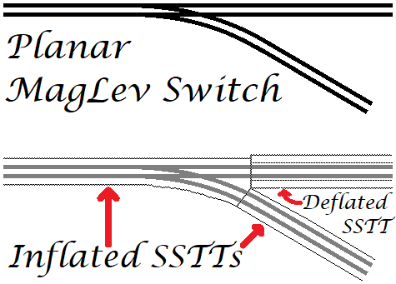
Each vehicle slides seamlessly from the monorail to the planar section, which then splits. The vehicle takes one path or the other, under control of the central system. It then slides seamlessly onto a monorail. Going in the other direction, a vehicle comes in from one of two directions, and leaves on the single exiting monorail.

The diagram to the left shows a Powell/Danby MagLev Switch, as seen from above, and how it would look covered by Soft-Sided Transportation Tubes (SSTTs). In this case, the lower arm on the right side is activated, and the upper arm is deactivated. The lower arm’s SSTT is inflated, while the upper arm is deflated, and effectively sealed off. For the purposes of this illustration, I am not using the more-advanced form, with crusher ballonets. Using crusher ballonets would be better, though.

Concerns about Solid Transportation Tubes (Pat.-Pend.)
There are three areas of concern with solid-sided transportation tubes. The most important has to do with emergencies. A tube can be heavily damaged due to an earthquake, an internal explosion, or an attack. A solid-sided tube would likely get bent in some way, and the vehicle will collide with it. Or, a vehicle can be stuck in a tube, and powerful blow torches would be needed to cut out the side of the tube. Most such transportation tubes, such as ET3 and Hyperloop, have tight tolerances between the tubes’ inner walls and the vehicles.

In contrast, a soft-sided tube can be rigged so that it can be easily cut in one direction, but not in the perpendicular direction. It could be modularized so that sections can be easily replaced. If a section of tube is damaged, it can be quickly removed, and the vehicles can run on the MagLev guideway, at slower speeds, until the tube is repaired. Those slower speeds are still 300-350 mph. Soft-sided tubes can have wider gaps between the tube walls and the vehicles, because the tubes exist merely to keep the air pressure low to reduce air drag. It might be possible to alternate soft- and hard-sided sections of a transportation tube, but limit the length of the hard-sided section to, at the most, 500 meters (1,640 feet).

The second concern is switching. Hard-sided Transportation Tubes present intractable difficulties in switching. For soft-sided tubes, it becomes easier, as discussed above

Lastly, there has to be some sort of entrance and exit from the tubes. It would be easier if the vehicles would enter and exit the tubes within an enclosed space, but that would require the vehicles to stop and then restart. Soft-sided tubes can be closed, and then open just in time to admit a vehicle. The outside air pressure would help push the vehicle into the tube, which subsequently would be evacuated. As the vehicle leaves the tube at the other end, the outside air will help slow the vehicle to its normal operating speed, 300-350 mph.

Options about Inflating SSTTs (Pat.-Pend.)

At this point, we have a few options. The SSTTs could be kept inflated almost all the time, or just during prime traffic time, or just when there is a vehicle or a small consist or convoy of vehicles (“on-demand”). Remember that several MagLev vehicles travelling together, using a Linear Synchronous Motor (LSM), are “riding a wave” on the guideway, and cannot collide. Therefore, they can be quite close together without any such danger.

If an SSTT is kept inflated all the time, then less energy will be needed, and there will be less wear on the structure of the SSTT. If it is deflated when traffic is light, then less air will leak out, but it costs extra energy to deflate and re-inflate the SSTT.

In the “on-demand” scenario, the ballonets would be individually pressurized to “inflate” the tubes in the vicinity of the vehicle, or of a convoy of vehicles. This makes things more complicated. First of all, this means the pumps will be working hard whenever a group of vehicles come through, and there will be flexing of the fabric of the SSTTs. If the vehicles are going at faster than the speed of sound, then measures must be taken that the inflation of the outer tubes is still subsonic. This can be done by inflating the tubes well before the vehicles get there, but then, how is this different than keeping them inflated all the time, or during prime travel time?

Note that, even if the vehicles are moving faster than the speed of sound, the sideways motion of the outer tube should be much less. Vanes affixed to the outer tube should direct the displaced air sideways, rather than in the direction of travel.

All in all, the “on-demand” scenario, where you inflate the tubes only when they “need” to be inflated, does not seem to be a good idea.

References:

[1] MAPS Maglev Power Storage System: https://www.youtube.com/watch?v=OE92_Ds6XvI&feature=youtu.be
[2] Water Train: http://www.readinessresource.net/assets/water_train_wtg.pdf
[3] Chinese Belt and Road Initiative: https://en.wikipedia.org/wiki/Belt_and_Road_Initiative
[4] "Powell and Danby's Grand Idea: 50 Years of Maglev History": (https://www.bnl.gov/video/index.php?v=514) especially between timestamps 16:25 to 20:45
[5] ibid. especially between timestamp 16:40 to 16:54
[6] ibid. especially between timestamp 31:40 to 37:04
[7] Linear Synchronous Motors: http://web.archive.org/web/20160317025046/http://maglev2000.com/works/how-03.html
[8] Linear Induction Motors (ala Bombardier) https://en.wikipedia.org/wiki/Bombardier_Innovia_Metro
[9] Maglev Trains with Ernest Fazio - Enviro Close-Up with Karl Grossman: https://www.youtube.com/watch?v=HAbKFSTOtYM&feature=youtu.be timestamp ~18:55
[10] ibid. timestamp ~18:00
[11] ibid. timestamp 5:14
[12] ibid. timestamp 8:37
[13] How Maglev Works: http://web.archive.org/web/20160305002420/http://maglev2000.com/works/how.html
[14] Project Bundling: https://www.fhwa.dot.gov/innovation/everydaycounts/edc_5/project_bundling.cfm
[15] One of America's most storied brands is no more: https://www.cnn.com/2020/08/03/tech/sprint-tmobile-brand/
[16] Initial National MagLev Network: http://www.magneticglide.com/assets/america-project.pdf
[17] The Perfect Synthesis http://web.archive.org/web/20181124160353/http://www.evworld.com/article.cfm?storyid=744
[18] LeviCar.com www.LeviCar.com
[19] Hyperloop www.teslamotors.com/blog/hyperloop
[20] California’s High-Speed Rail (HSR) http://www.hsr.ca.gov/
[21] hexOgrid: http://www.hexOgrid.com/
[22] Vactrain http://en.wikipedia.org/wiki/Vactrain
[23] Einstein-Rosen Bridge http://en.wikipedia.org/wiki/Wormhole
[24] Star Trek: Deep Space Nine http://en.memory-alpha.org/wiki/Bajoran_wormhole
[25] Critique of Hyperloop http://www.LeviCar.com/Hyperloop

